**Adding a New Product in the Database**

**Screenshot**

**index.jsp**

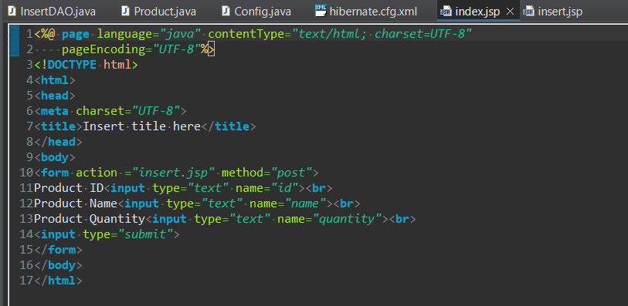

**insert.jsp**

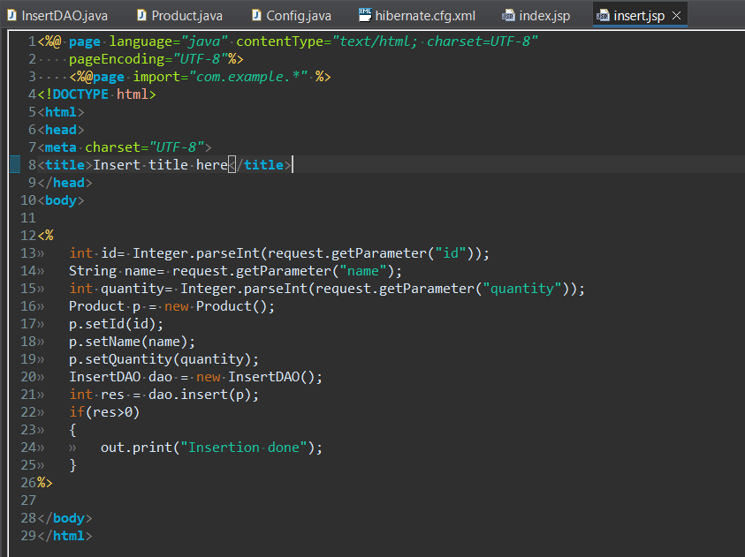

**InsertDAO.java**

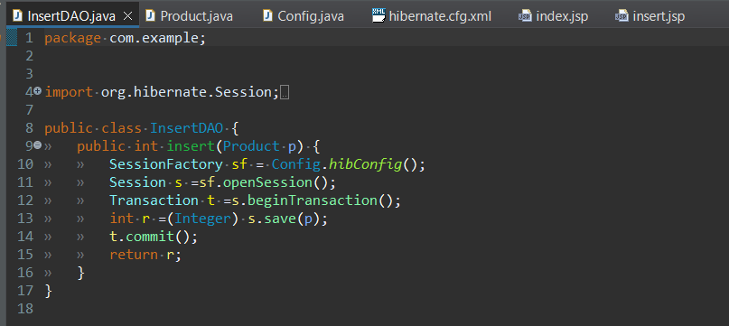

**Product.java**

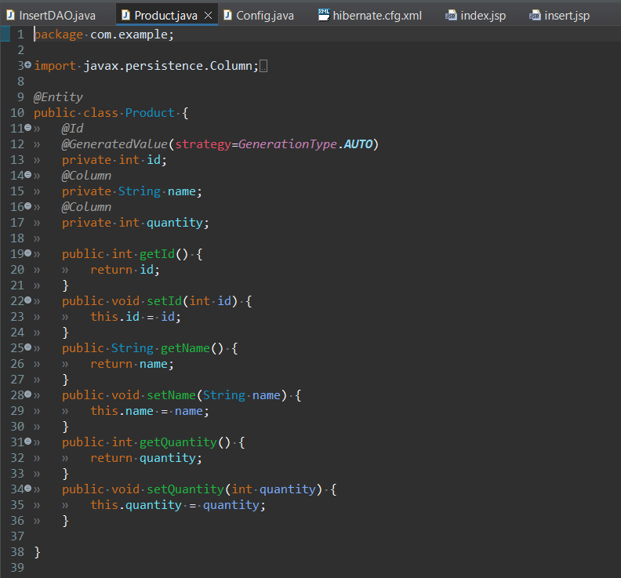

**Config.java**

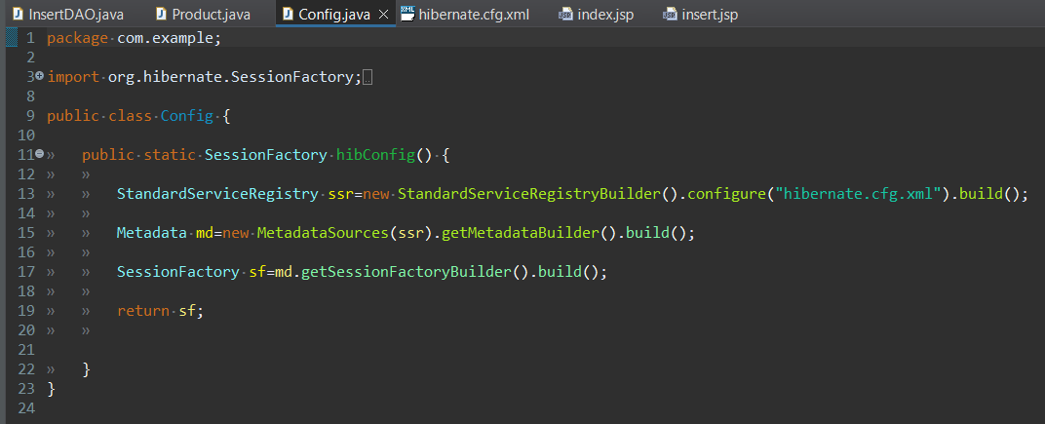

**Hibernate.cfg.xml**

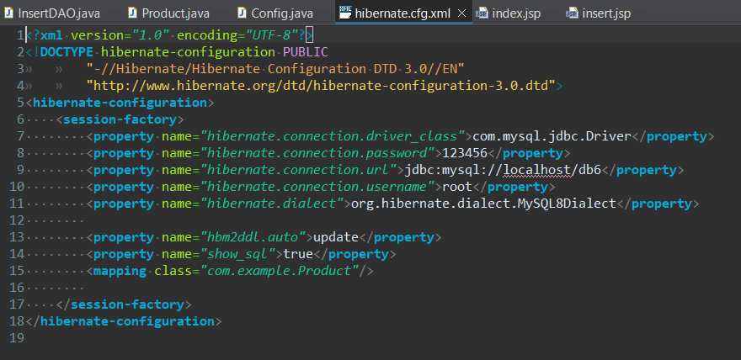

**OUTPUT**

